

**Looping Statements**

**Dhruvin Dholiya**



1. **Write C program to print 1 to 10 number.**

* **Code:**

#include<stdio.h>

int main() {

int i;

for (i=1; i<= 10; i++) {

printf("%d\n", i);

}

return 0;

}

* **Output:**

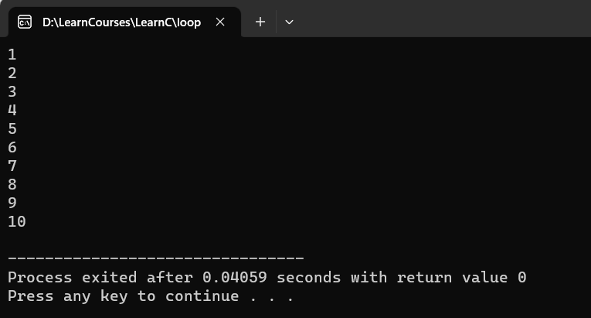

1. **Write C program to print 40 to 31 number.**

* **Code:**

#include<stdio.h>

int main() {

int i;

for (i=40; i>= 31; i--) {

printf("%d\n", i);

}

return 0;

}

* **Output:**

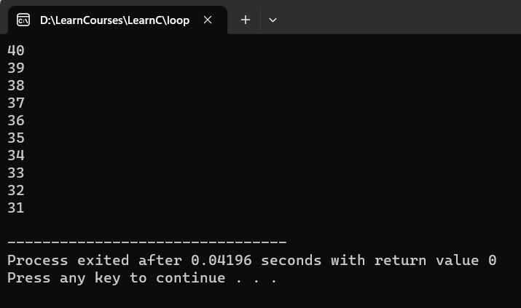

1. **Write C program to print odd number from 80 to 100.**

* **Code:**

#include<stdio.h>

int main() {

int i;

for (i=80; i<= 100; i++) {

if (i % 2 == 1) {

printf("%d\n", i);

}

}

return 0;

}

* **Output:**

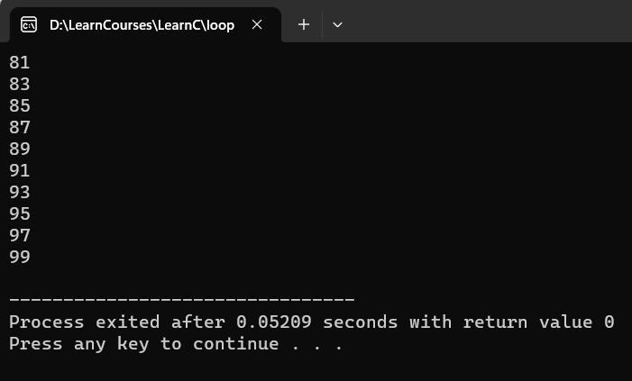

1. **Write C program to print number that are divisible by 5 from 25 to 50 number.**

* **Code:**

#include<stdio.h>

int main() {

int i;

for (i=25; i<= 50; i+=5) {

printf("%d\n", i);

}

return 0;

}

* **Output:**

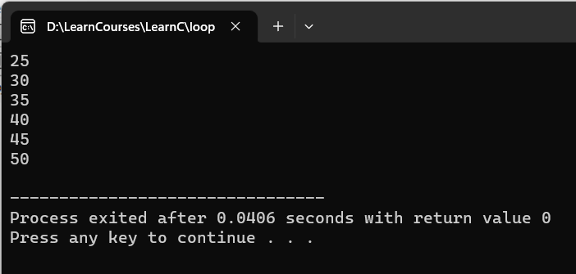

1. **Write C program to print to print A to Z character.**

* **Code:**

#include<stdio.h>

int main() {

char i;

for (i='A'; i<='Z'; i++) {

printf("%c\n", i);

}

return 0;

}

* **Output:**

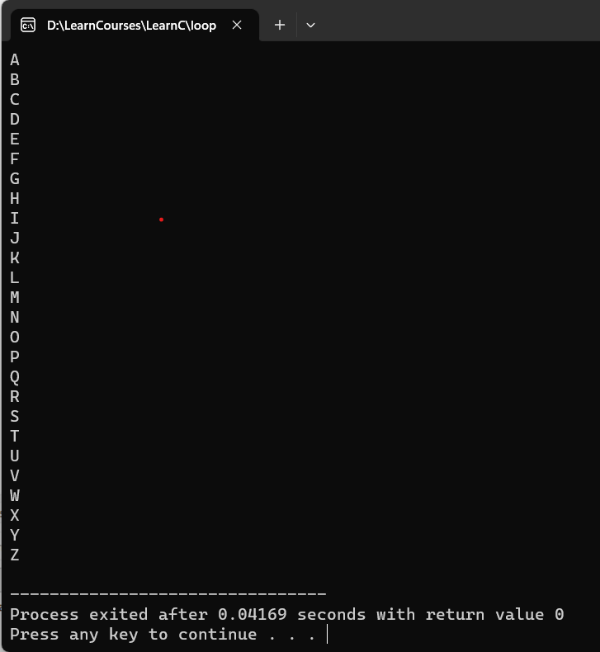

1. **Write C program to print multiplication table of any number.**

* **Code:**

#include<stdio.h>

int main() {

int i, num;

printf("Please enter any number: ");

scanf("%d", &num);

for (i=1; i<=10; i++) {

printf("%d * %d = %d\n", num, i, num*i);

}

return 0;

}

* **Output:**

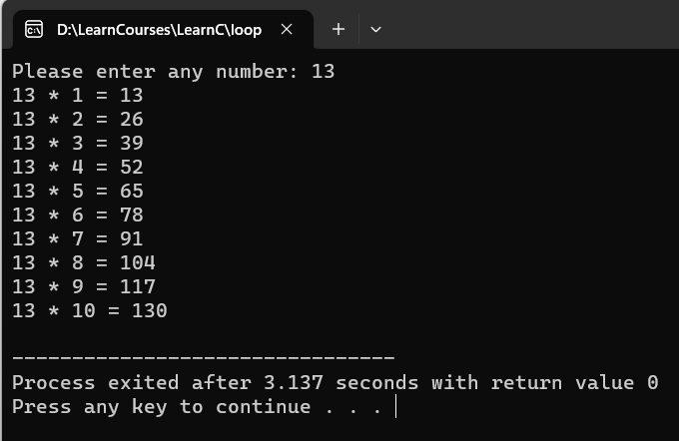

1. **Write C program to count number of boys whose weight is less than 50kg and height is greater than 170cm.**

* **Code:**

#include<stdio.h>

int main() {

int i, count=0, students;

float height, weight;

printf("Please enter count of students in your school: ");

scanf("%d", &students);

for (i=1; i<=students; i++) {

printf("Please enter weight and height: ");

scanf("%f %f", &weight, &height);

if (weight <= 50 && height >= 170) {

count++;

}

}

printf("Count of boys is: %d", count);

return 0;

}

* **Output:**

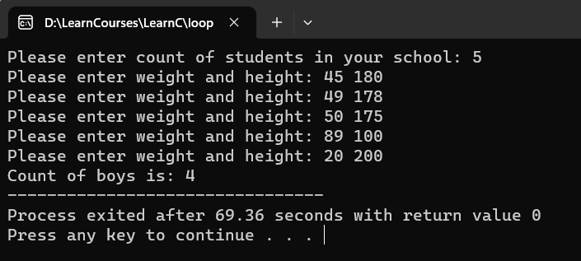

1. **Write C program to find ratio of (a-b) and (c-d) of any three number. If c and d is equal than not to find ratio.**

* **Code:**
* **Output:**

1. **Write C program to calculate factorial of a number.**

* **Code:**

#include<stdio.h>

int main() {

int i, num, factorial;

printf("Please enter any number: ");

scanf("%d", &num);

for (i=1; i<=num; i++) {

factorial = factorial*i;

}

printf("\nThe Factorial of %d is: %d", num, factorial);

return 0;

}

* **Output:**

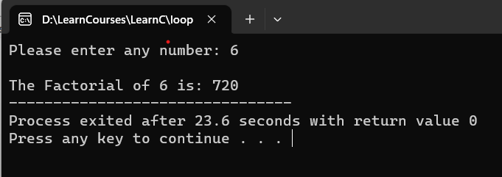

1. **Write C program to give sum of n numbers.**

* **Code:**

#include<stdio.h>

int main() {

int i, num, sum=0;

printf("Please enter any number: ");

scanf("%d", &num);

for (i=1; i<=num; i++) {

sum = sum + i;

}

printf("\nThe sum of %d is: %d", num, sum);

return 0;

}

* **Output:**

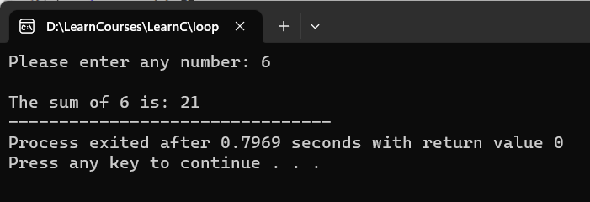

1. **Write C program to give average of n numbers.**

* **Code:**

#include<stdio.h>

int main() {

int i, num;

float avg;

printf("Please enter any number: ");

scanf("%d", &num);

for (i=1; i<=num; i++) {

avg = avg + i;

}

avg = avg / num;

printf("\nThe sum of %d is: %f", num, avg);

return 0;

}

* **Output:**

